SIP Integration

How to sip from BMW SVN can be referenced for overview of sip update

SIP: File location in SVN for IPB

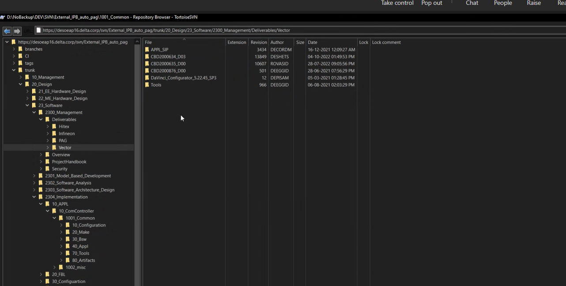

For 5DH

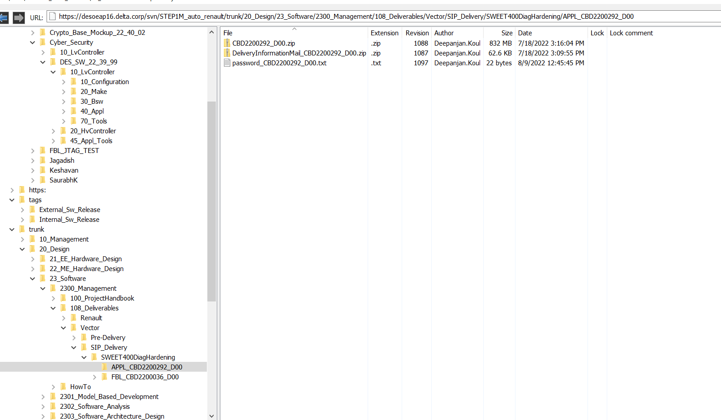

.exe file is executed with the password and a path of the folder is provided

After Extraction into a folder

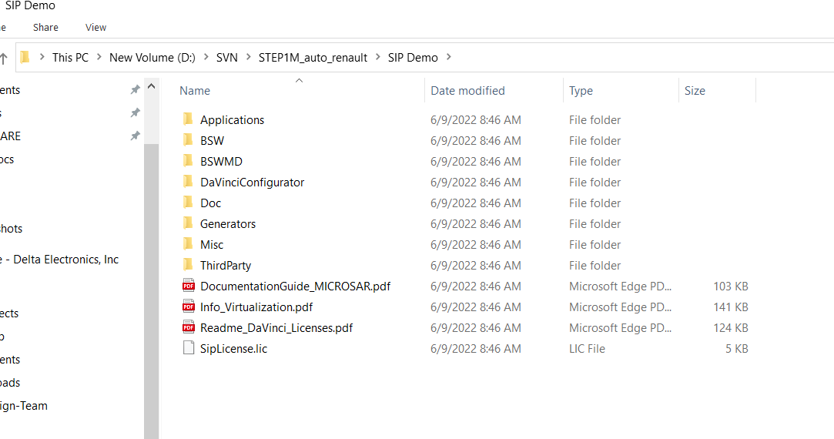

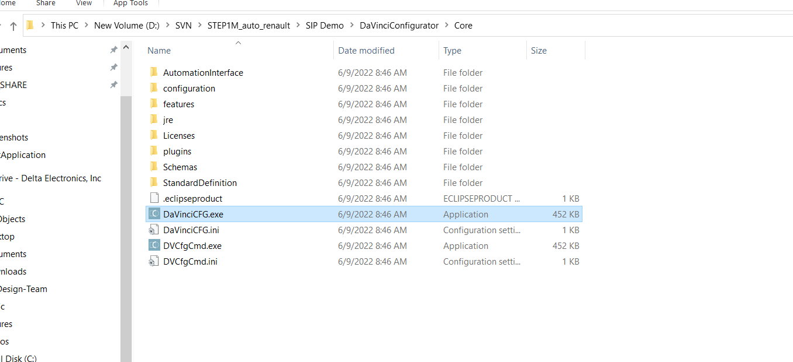

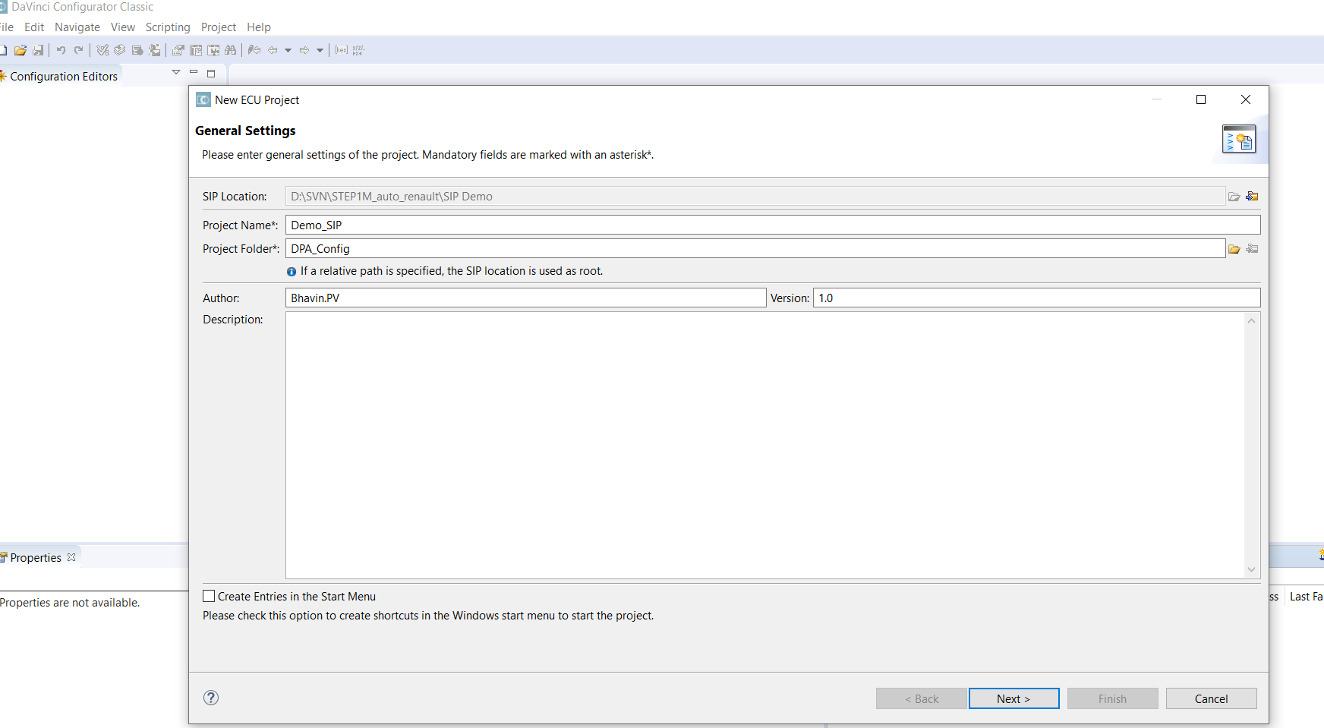

Here project folder gives it as: D:\SVN\STEP1M_auto_renault\ZDemo_Project\10_Configuration\60_DPA_CONFIG

This is how it is in 5DH

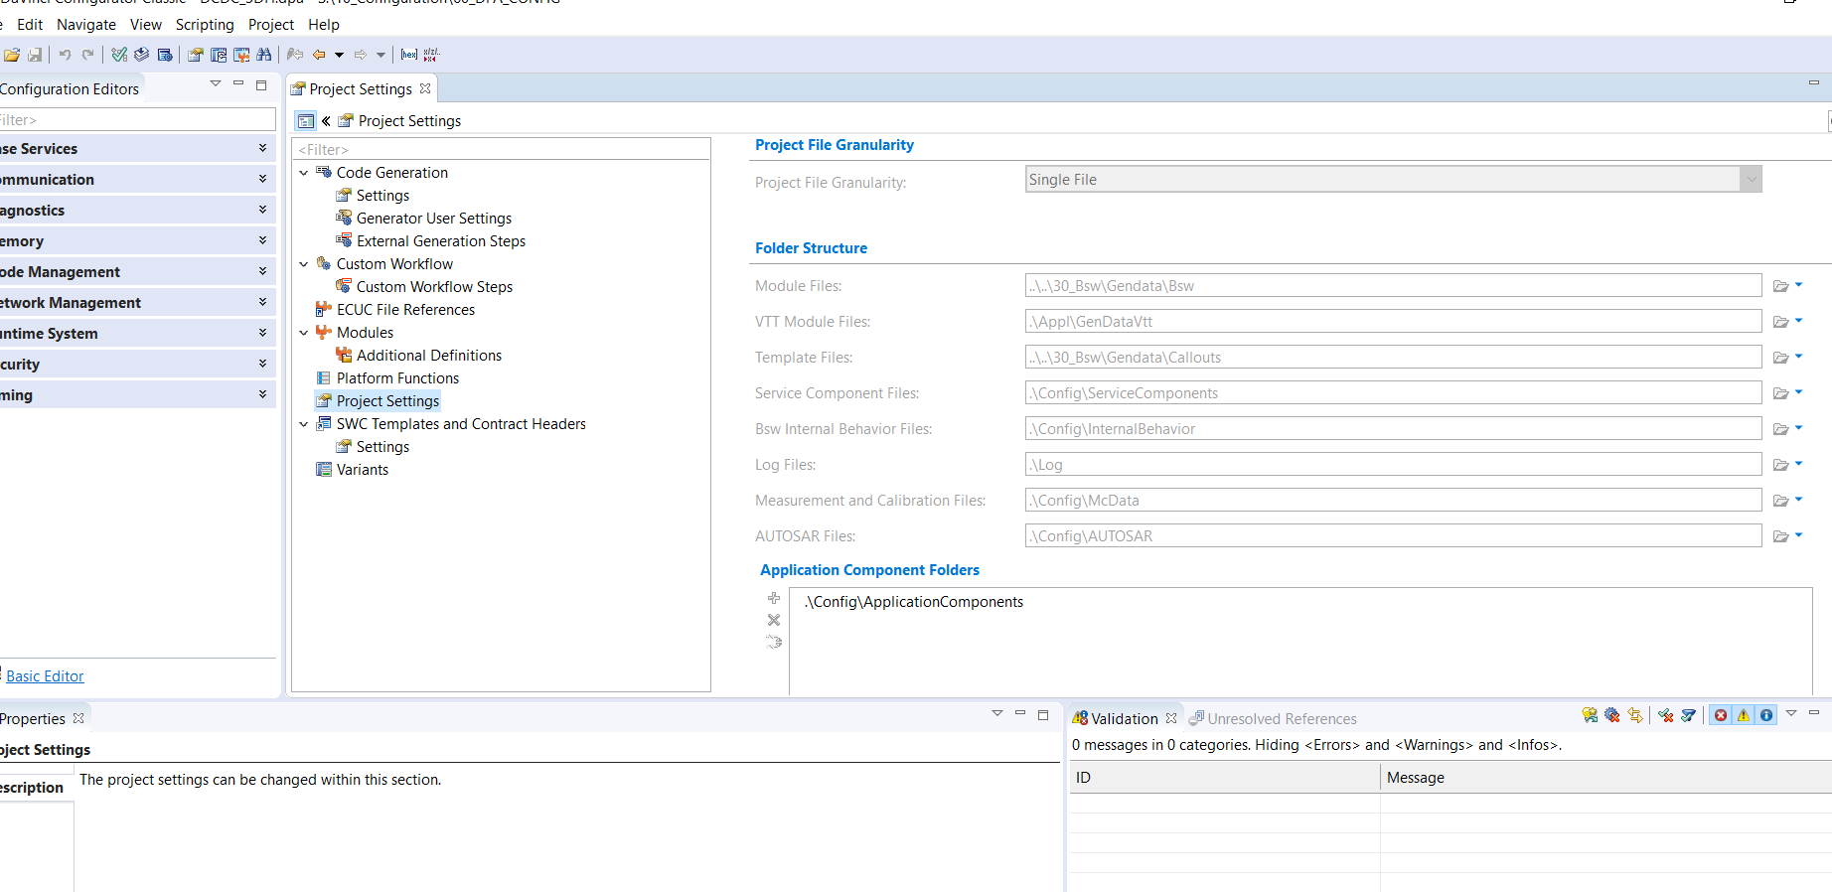

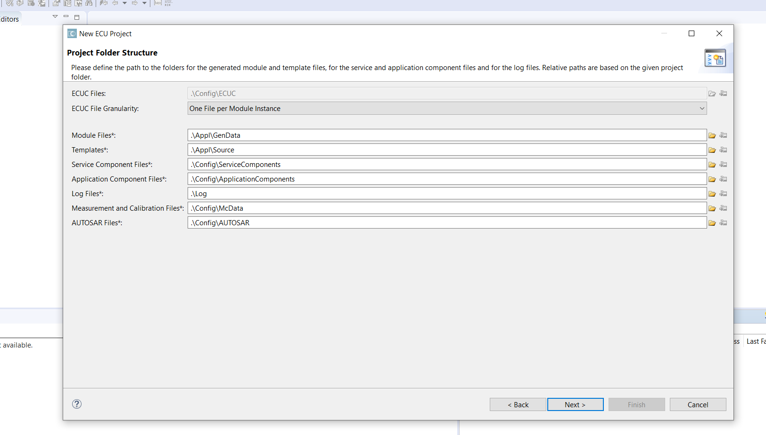

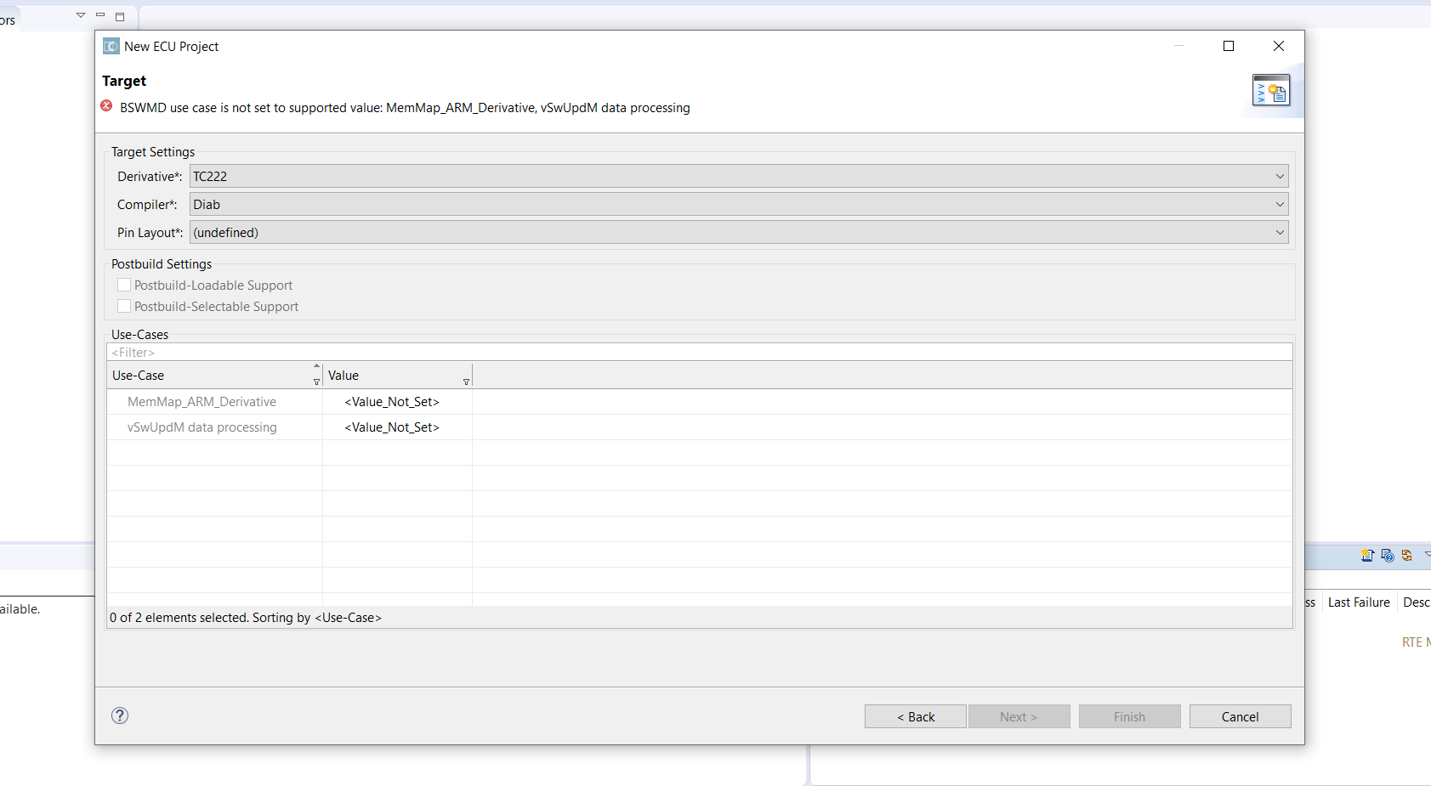

Go to the current DPA file of the project and see the project settings in case you need while doing sip update

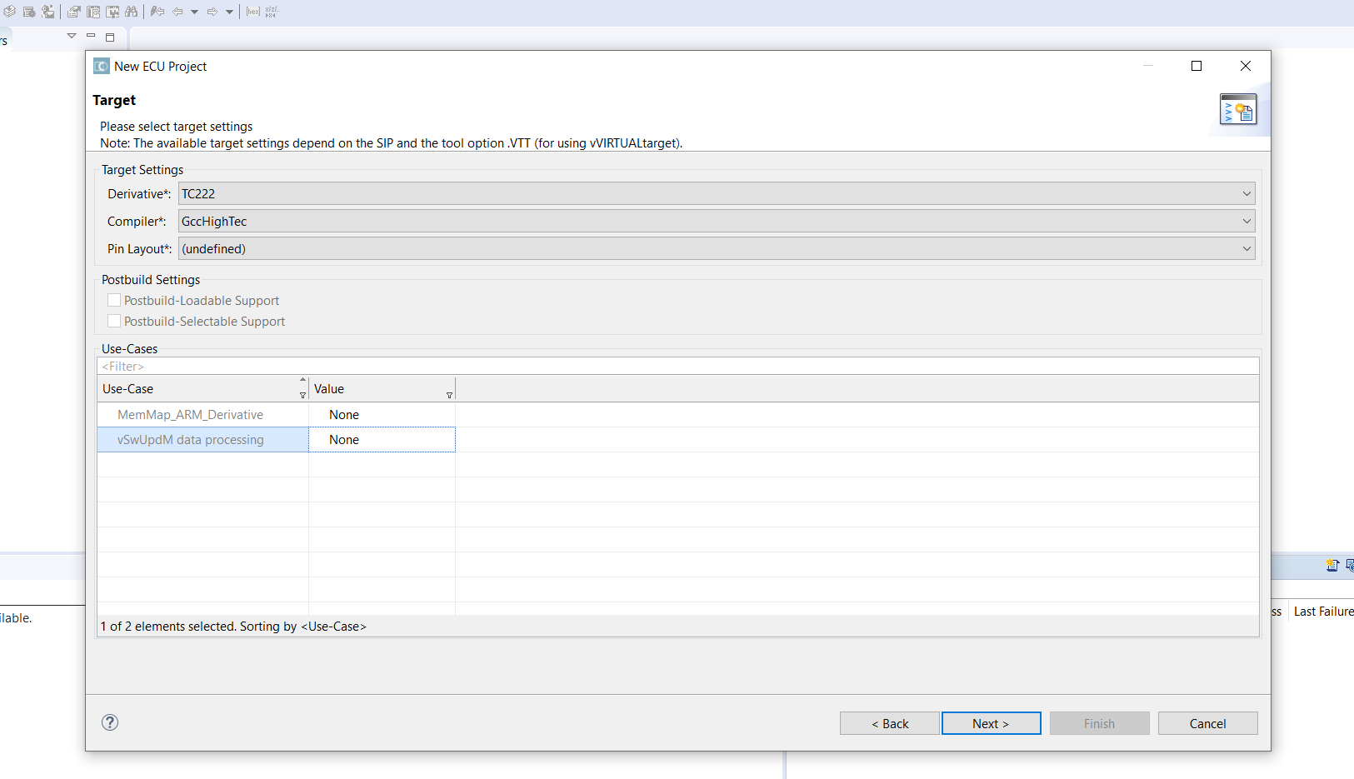

Here I gave none as it was in the project dpa which we are working now

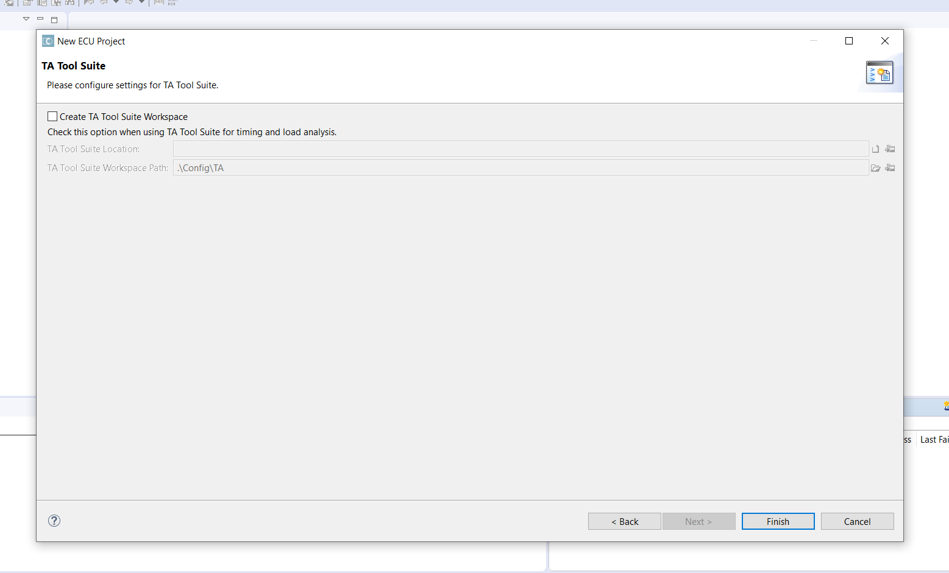

Give Finish

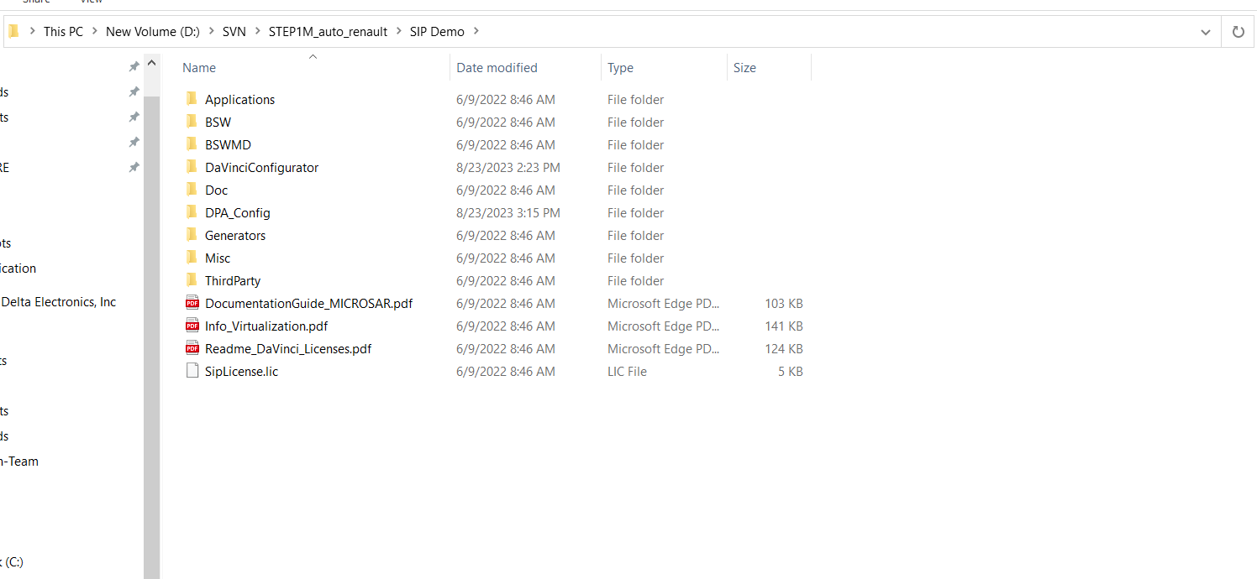

Now DPA_Config (as given) is created in the SIP demo

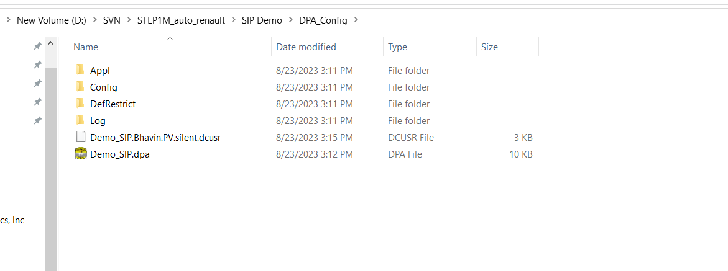

With the name given as Demo_SIP.dpa -------step (1)

This DPA_Config replaces the dpa folder already existed in the project or will become the part of 10_configuration .

Now a new demo project is created with same file structure

In 70 Tools ->60_ARToolChain, Add the SIP Files as how extracted

Copy paste the BSW files in SIP folder (which is static i.e. it doesn’t change) to the static folder of each BSW module files in 30_BSW. Create a Config folder for all BSW modules where the Gen data files from configurator get updated as given while creating the project settings)

40_APPl is kept same (for sip update) or create it newly for new project

10_configuration remain same except for the dpa folder(60_dpa_config), here replace the dpa folder with the new dpa folder we created by doing the above step (1)

If change in MCAL then do the MCAL integration

MCAL Integration

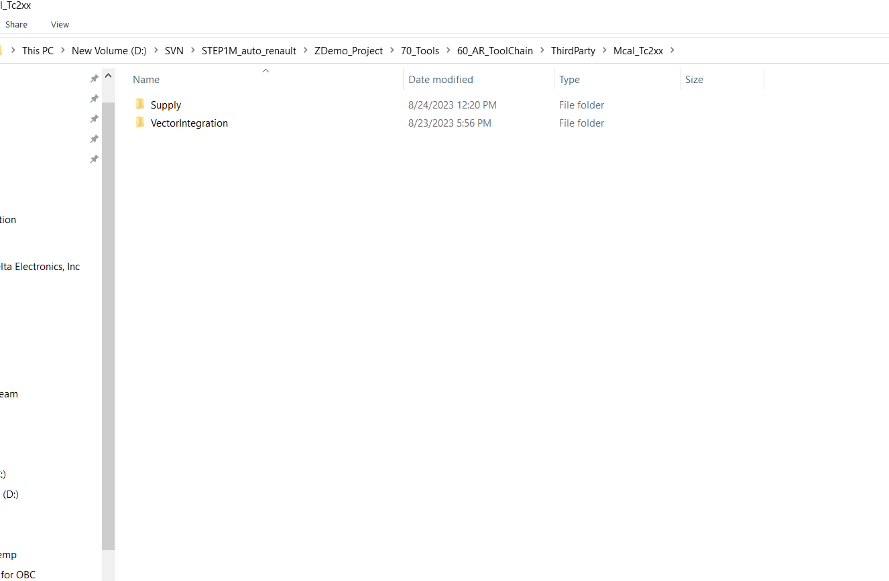

Add the supply folder which you can get from third party of the project 70 tools

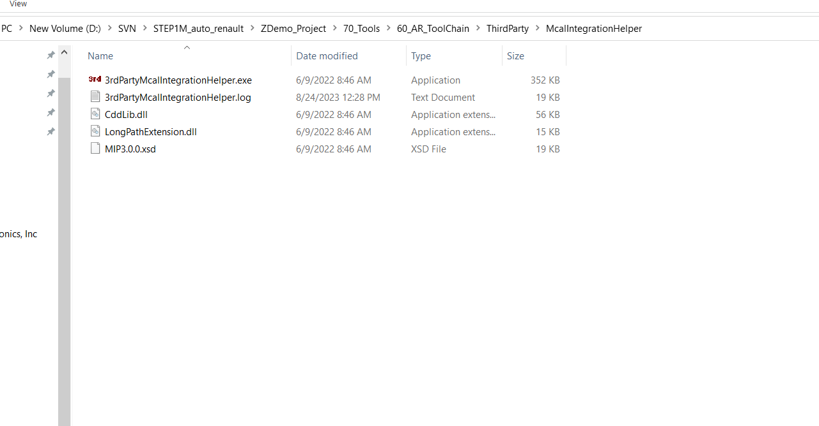

Now run the .exe file

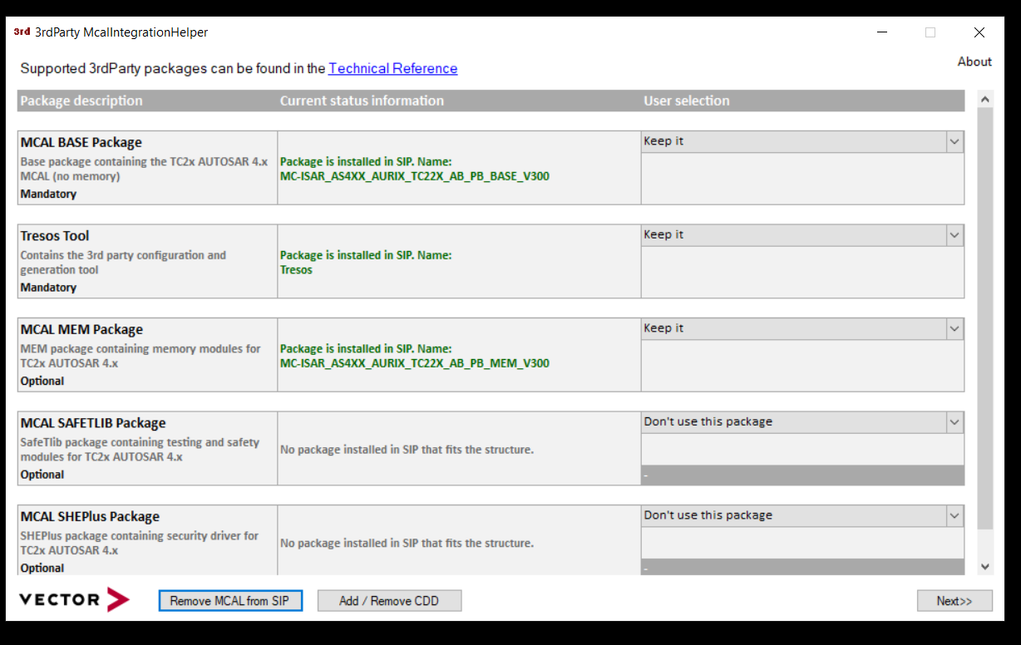

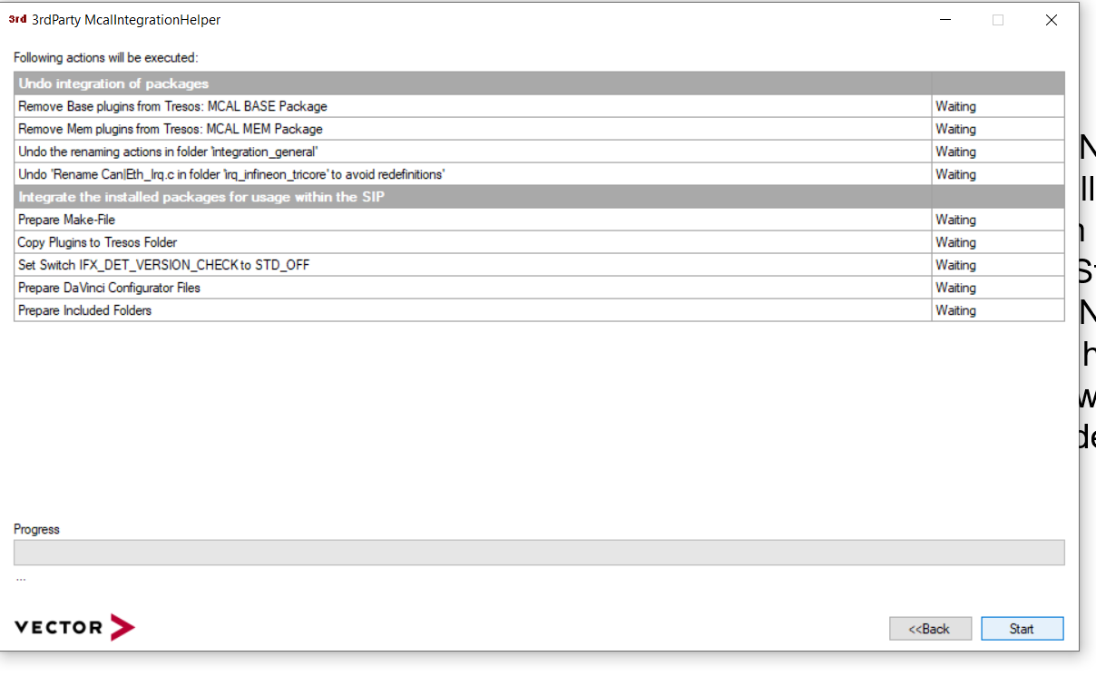

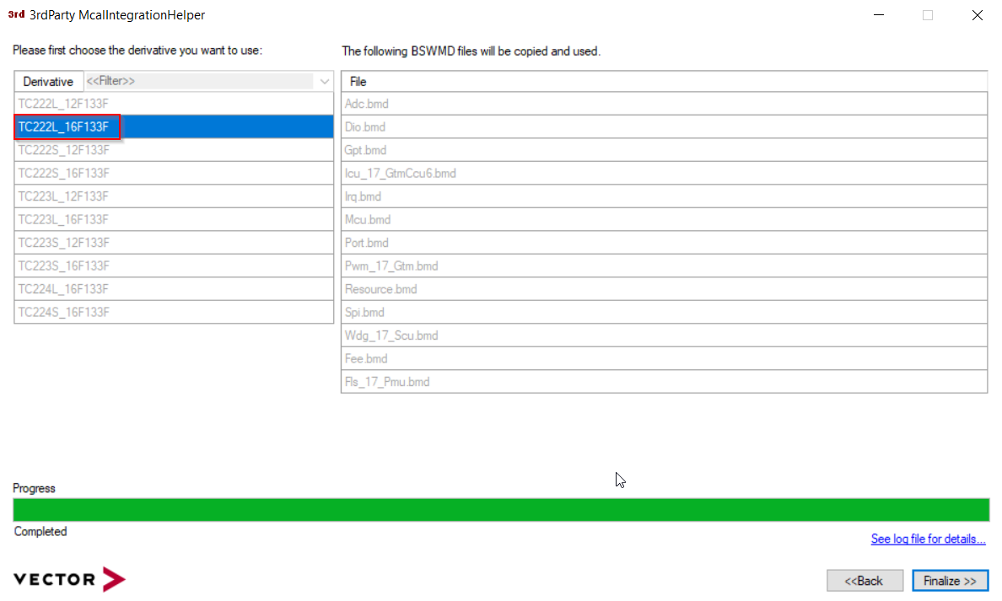

**D:\SVN\STEP1M_auto_renault\SIP Demo\Doc\UserManuals For references**

**S:\10_Configuration\60_DPA_CONFIG\Config\ECUC** from this path copy the ECUC arxml files for SIP Update since this arxml will have all the configured data

To the ECUC folder of the new dpa folder

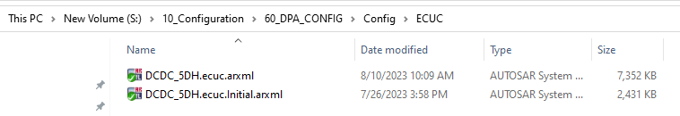

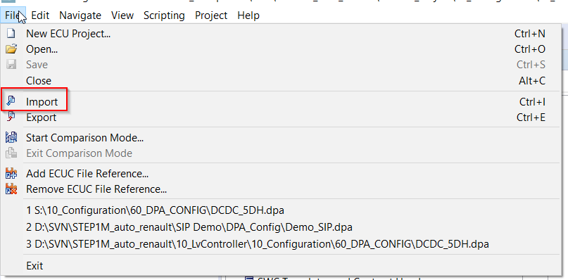

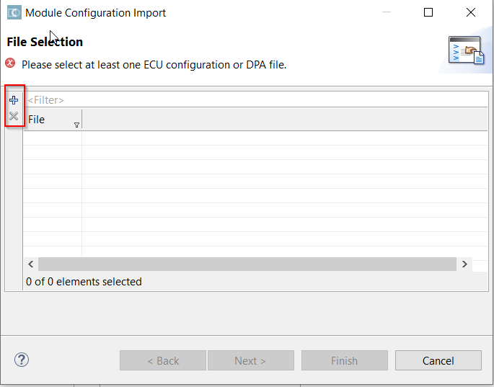

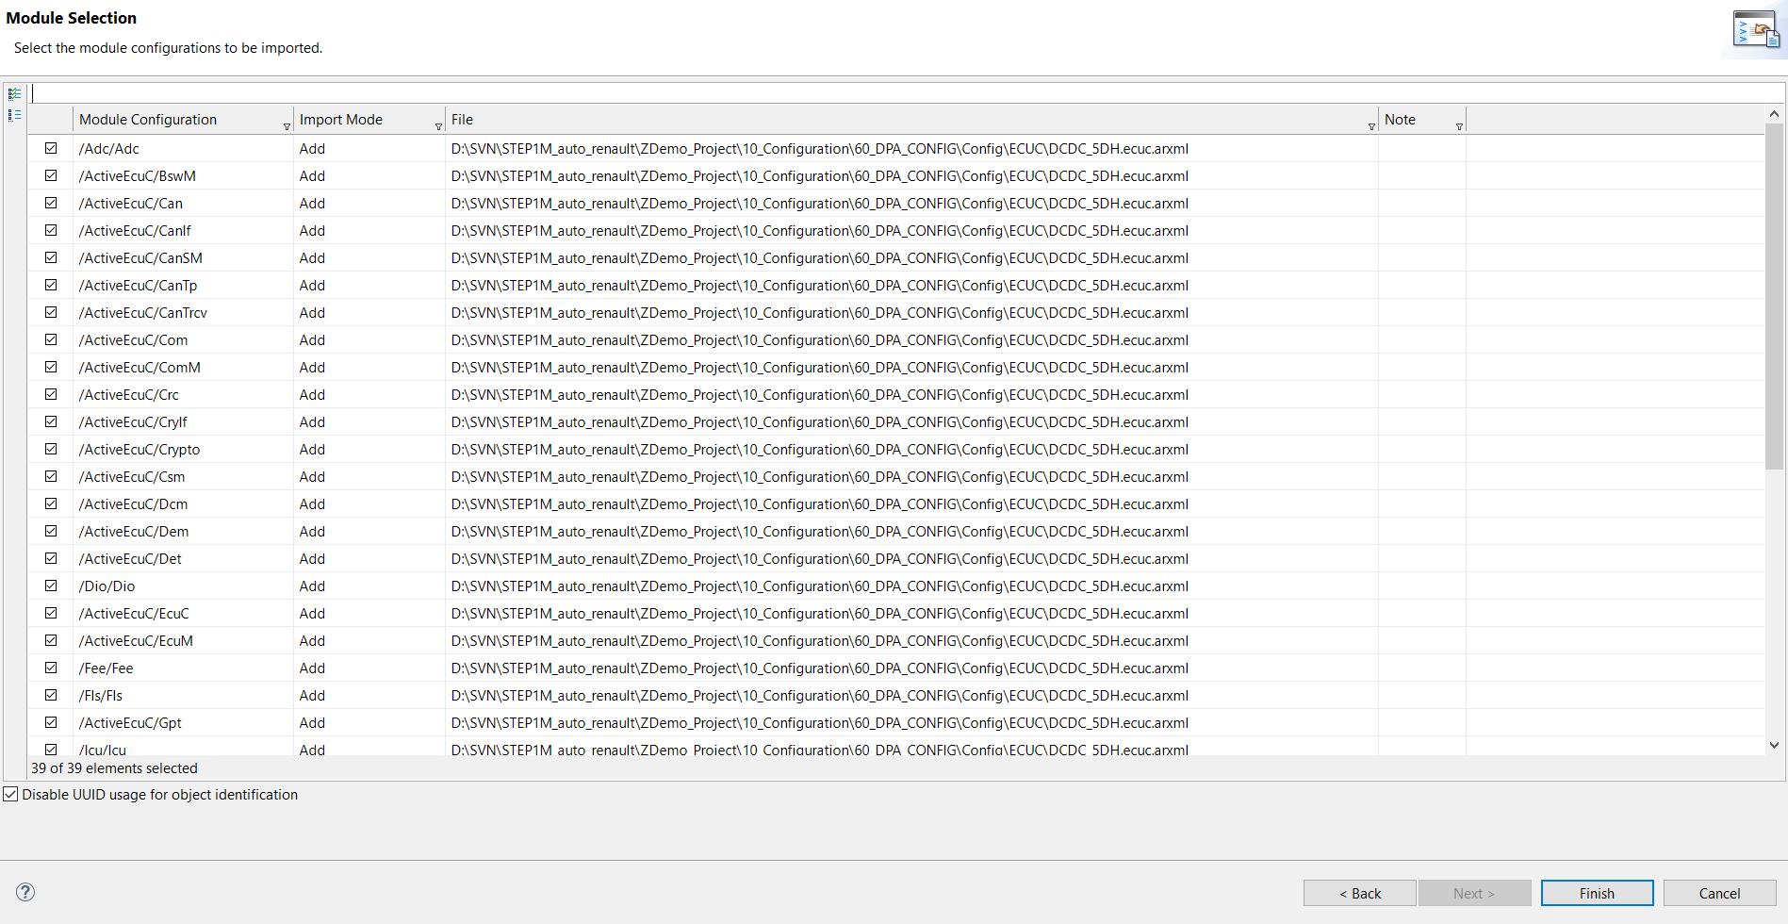

Save and synchronize the dpa file

Add all the files and select all

Finish

Save the Cfg and Synchronize

Add the input files (project settings -> input files)

Add the cdd and dbc by comparing with the old dpa file

Now update the workflow and save

Need to solve the errors

Open developer

Import all the arxml related to swc

Copy and paste component type folder from S:\10_Configuration\60_DPA_CONFIG\Config\Developer\ComponentTypes

To

D:\SVN\STEP1M_auto_renault\ZDemo_Project\10_Configuration\60_DPA_CONFIG\Config\Developer\ComponentTypes

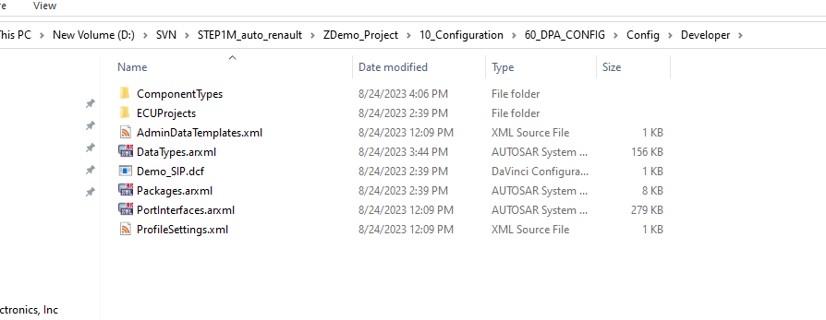

Now open Developer

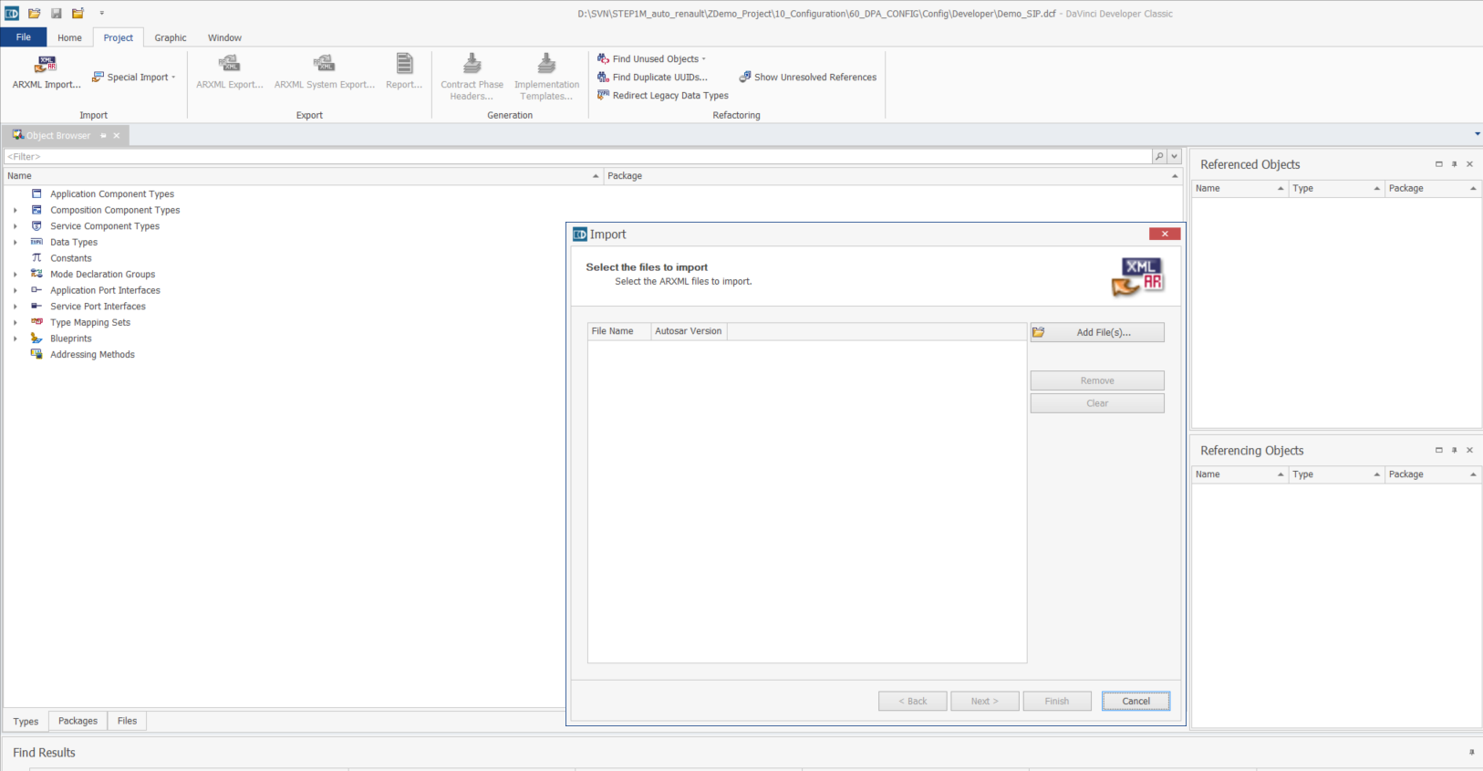

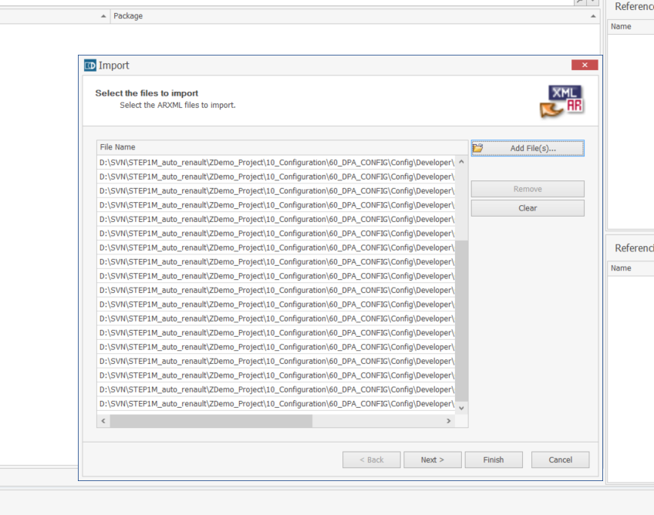

Import the cdd and dbc files into (input files of project settings )

Special import and normal import

Compare with old dpa files for changes

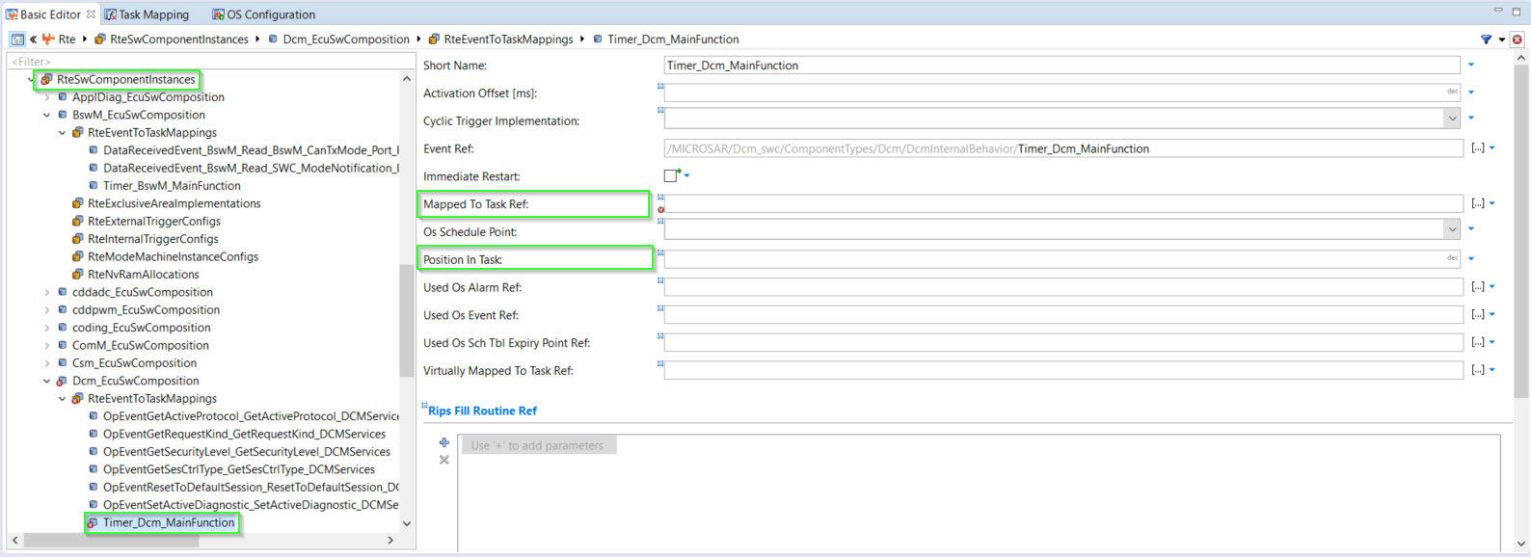

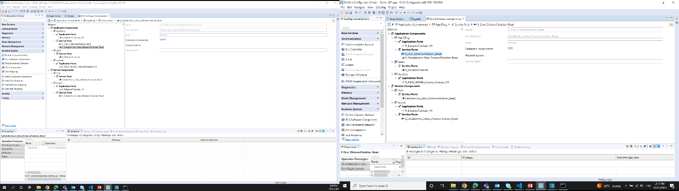

Open the New sip folder

Copy paste the content to AR toolchain of the existing project

In 70 Tools ->60_ARToolChain, Add the SIP Files as how extracted

Do the Mcal integration in 60_ARToolChain

Do the DPA creation as told above but folder location give the 10_Configuration location

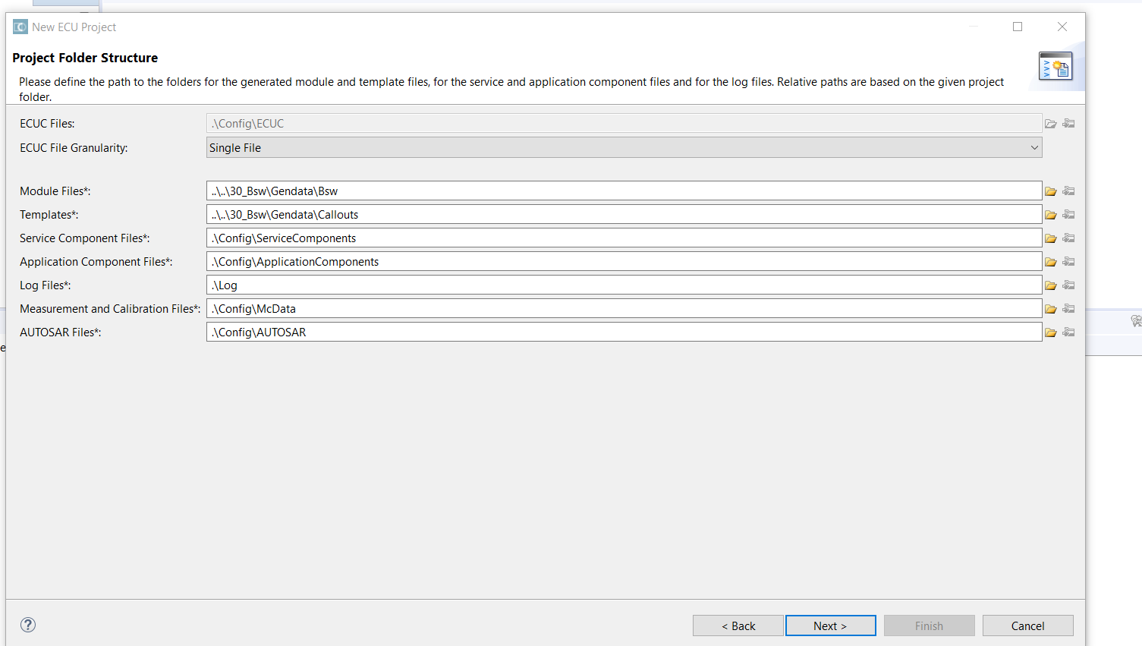

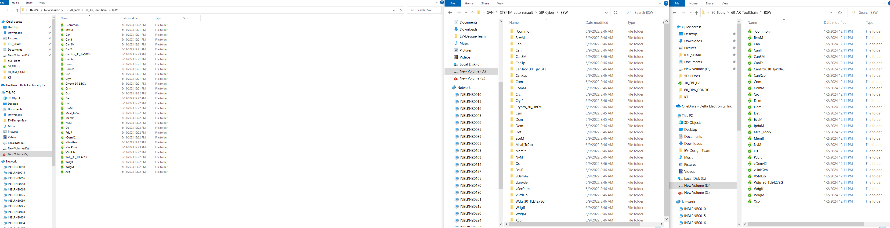

After creating DPA

Added input files and updated project configuration -> on doing this you will get some BSW modules in basic editor

Added modules from settings ie the MCAL modules -> on doing this all modules will get added to the basic editor

Now Files -> Import -> Import the ARXML of DCDC_5DH DCDC_5DH.ecuc.arxml

After Importing ECUC ARXML ( DCDC_5DH DCDC_5DH.ecuc.arxml )

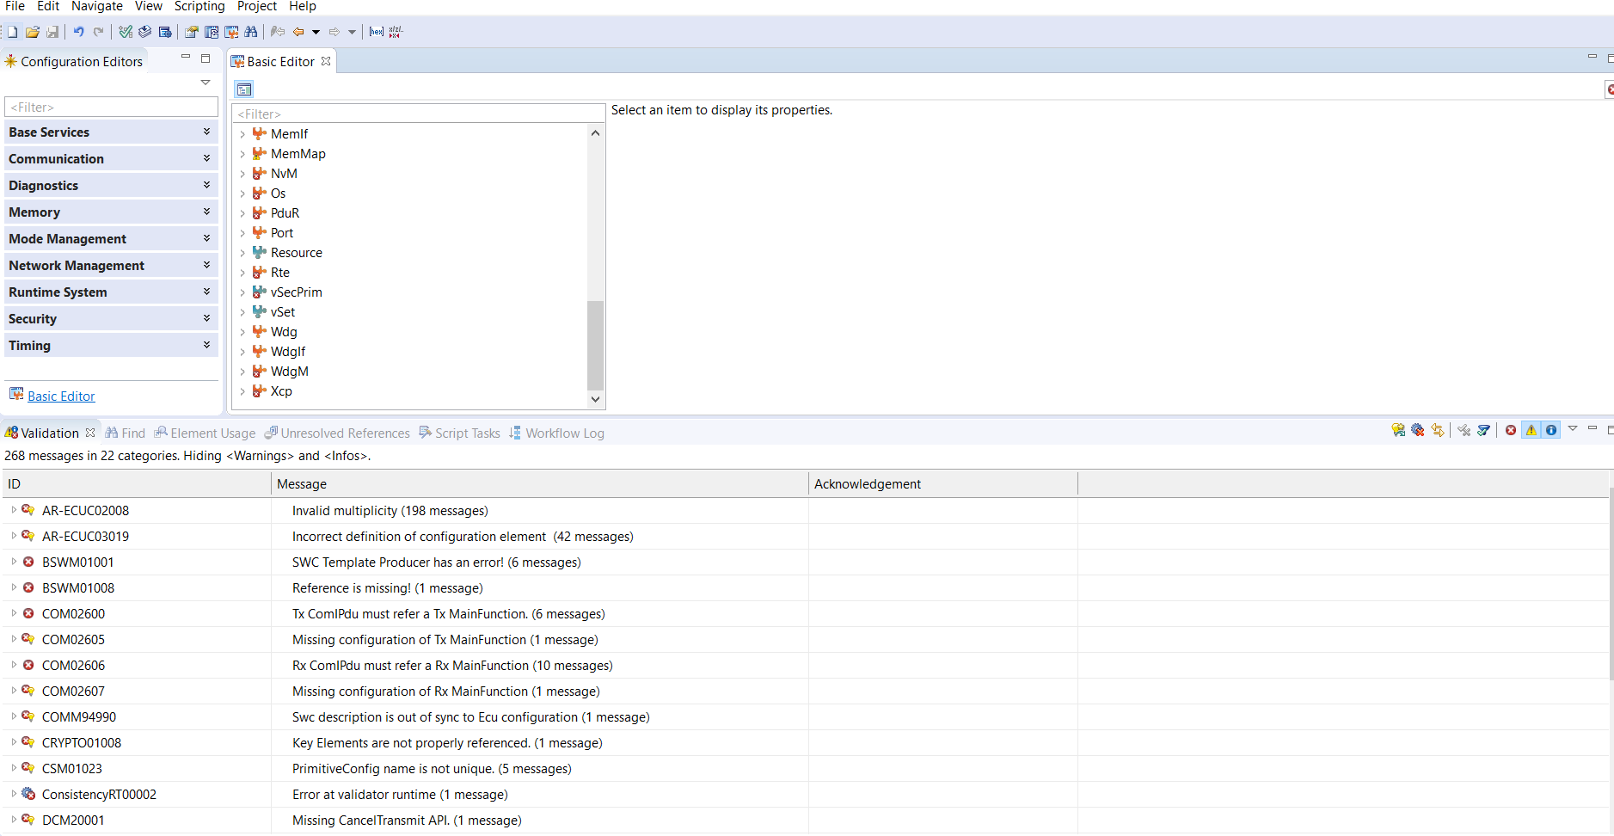

**Vector Meeting**

